|  |  |  |
| --- | --- | --- |
| **LAB211 Assignment** | **Type:** | **Short Assignment** |
| **Code:** | **57c59c3a622c1268 6880451e8f384bad** |
| **LOC:** | **100** |
| **Slot(s):** | **5** |

**Title**

Memory cache management program

**Background Context**

Memory caches are the system caches data and objects in memory. It is often used to speed up dynamic database-driven websites by caching data and objects in RAM to reduce the number of times an external data source (such as a database or API) must be read.

In the memory cache system (mem-cache), each item usually has a key, an expiration time. When an item is requested, it checks the expiration time to see if the item is still valid before returning it to the client.

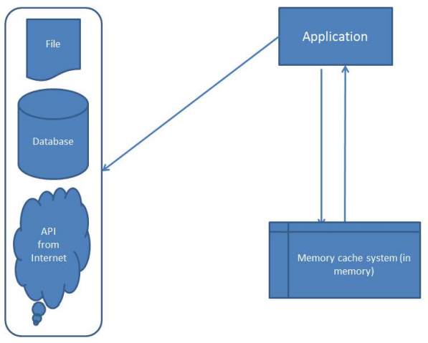

**Program Specifications**

Design a Simple memory cache system program that allows cache data in memory to reduce number of time read data from external sources.

**Function details: Suggestion:**

Program use a HashMap store Object, and wrapper class contains object and expired time.

Expectation of User interface:

**Guidelines**

1. Write wapper class FuCached contains 2 field *Object data*, and *Date expiredDate*.

2. Write class FuMemoryCached contain static field HashMap cached.

a) *public boolean putObject(String key, Object object, int timeTolive).*

o This method will put *Object* to *HashMap<String,FuCached> cached* cached, (new a instance of FuCached, set data, expiredDate )

b) *public static Object getObject(String key)*

o This method will return Object from HashMap cached if key exist in HashMap*<String,FuCached>* cached and current time < expiredDate of Object. (remember remove object if current time > expiredDate of Object)

c) *public static boolean clean (String key)*

o This method remove Object have key equal key from HashMap cached

d*) public static boolean cleanAll()*

o This methed will remove all Object in HashMap cached

3. Write Main class Main test Program you wrote (example : read student from a file and put to cache)

**Note:**

In fact memory cache system must resolve the problem concurrent user. (Example: the same time there are two processes that call method putObject) . Thus, try to research about synchronization mechanism in java. Suggestion: search google with some keyword like: synchronized, thread safe.